Grade 2/3 Word Find
Instruments of the Orchestra
Name_________________________

K T Q M W N Q Q L N E U S O C
I N U A L S N Y E N O B O E C
Y R D M Z F X N O X J U B T T
D F I U G F F B N F G A Q G L
T E B M M K M R R W A L O I V
E W P F D O O E T R U M P E T
N N M W R P N L S U C L A V U
I Y O T R C Y V L M J F B I C
R C Y H H S S A B E L B U O D
A V H H P P Z V Q U C V T L O
L W O I T O G I T J Y X U I D
C R N R M L X E M N U W C N R
N S D K K E U A K H Z S Z T D
V E C V V Z S E S F X K C X R
V X N V N T N S R E Z K L R F
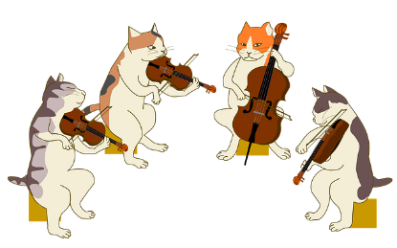
CELLO
CHIMES
CLARINET
DOUBLEBASS
DRUM
FLUTE
FRENCHHORN
OBOE
SAXOPHONE
TROMBONE
TRUMPET
TUBA
VIOLA
VIOLIN

